Short Story

Monday, February 02, 2015

2:36 PM

**#1 - 1 - The Sword Tree**

Monday, January 19, 2015

3:18 PM

**\*\*\*\*\*\*\*\*\*\*\*\*\*\*\***

**1.1.1 Overview**

**\*\*\*\*\*\*\*\*\*\*\*\*\*\*\***

The place is set where exhibits a giant tree. Where inside lies a magical fruit that can heal and replenish life.

The fruit looks like a shining apple or a starfruit, it glows above the the table at the center of every room.

Before people living near of it are permitted to enter and pick the fruits freely. But now, it was taken over by a man who wants to take business of it.

Suited in armor, he was the leader of the Guards who attacked Rolan inside the tree and the father of a pretty girl. He owns a mysterious Giant weapon. (My idea of him is like a calamity.)

He uses that weapon to make fear that if people tries to take a fruit from that tree, their relatives or family will be killed in an instant.

What he want everone to pay him for them to enter the tree.

The purpose of the Giant tree is to make a unique secret dungeon can be accessed after finishing this side quest.

**History:**

*Hundred years before, there is an ruined mansion guarded by a boy. The Ruined Mansion's roof has a hole on it where the light passes thru. That light passes thru lits a space where small plants are placed. It is guarded by a Boy. Eventually, the mansion is planned to be destroyed. And when the boy learned about it, the boy asked for help to the neighbors to stop the authority to do it. This will reveal that the boy is the son of the mansion's owner. Later, the boy received from his step parents that it will not be destroyed, so he believed in it but later it will revealed as a joke. So on the day when the mansion is planned to be destroyed… the boy is inside it, planning to plant more as he is putting many seeds. The mansion is destroyed including the boy.*

*Hundred years later, one of the seeds grows, and mysteriously shaped like a sword, it seems that the tree magically inherits the mansion's interior design.*

**\*\*\*\*\*\*\*\*\*\*\*\*\*\*\*\*\*\***

**1.1.2 Key Ideas**

**\*\*\*\*\*\*\*\*\*\*\*\*\*\*\*\*\*\***

1. (Rewards) Grants you a divine defense pendant that gives 70% evasion.
2. (Game idea) A battle
3. (Game idea) Time limit mission.
4. (Game idea) A side scrolling mini game (Collect the Super Fruit inside the dungeon.)
5. (Setting) A giant tree with an interior similar to a mansion. This is a special dungeon.
6. (Characters) Magical armors or robots runned by a mysterious power related to the power of the obelisk.

**\*\*\*\*\*\*\*\*\*\*\*\*\*\*\*\*\***

**1.1.3 Music Idea**

**\*\*\*\*\*\*\*\*\*\*\*\*\*\*\*\*\***

1. <https://www.youtube.com/watch?v=UQkxNbgohPg>

**\*\*\*\*\*\*\*\*\*\*\*\*\*\*\***

**1.1.4 Visual Idea**

**\*\*\*\*\*\*\*\*\*\*\*\*\*\*\***

1.1.4.1 - Reference

1.1.4.2 - Color Keys

1.1.4.3 - Design

**\*\*\*\*\*\*\*\*\*\*\*\*\*\*\***

**1.1.5 Flow Chart**

**\*\*\*\*\*\*\*\*\*\*\*\*\*\*\***

***\*Exploration\****

Rolan first enter to a path that leads to a cave, he noticed it was entirely guarded. Upon entering it there is another open path that will skip this area. If Rolan approaches the Guards it will trigger an event. Guards will start to act and attack you as the place is forbidden.

***2 possible events:***

***\*Side Quest - Get thru the dungeon path - A\****

If Rolan managed to go thru the path, beating guards and exit safely. It will show a special event.

The guards will report to their leader what happened, but the leader just ignore it because he is busy having lunch with her daughter, saying that they are having an important discussion.

***\*Side Quest - Get thru the dungeon path - B\****

If Rolan failed, it will show a special event.

He will be taken inside the prison cell, he will see beside a glowing fruit, and if he ate it, it will recover his life. Rolan must get away inside the cell. If Rolan managed to escape, he will see a secret room where a Giant Mechanical Armor is standing. After that, Rolan will return halfway to the exit of the dungeon.

After getting outside, he will a boy walking near the tree and when he got close, the Guards saw him and kicked him. And when the Guard tries to get the boy to throw away, Rolan acts to stop the Guard, initiating a battle scene.

After the battle, the guards will report to their leader what happened, but the leader just ignore it because he is busy having lunch with her daughter, saying that they are having an important discussion.

***\*Exploration\****

Meanwhile, Rolan enters the village, he met a working man beside a house. That man talks about making a fun game getting fruits from that tree. He also said, that he interested of selling those fruits to other countries… but his Son don't like that idea."

Rolan next goes to the room where the boy is. The lady told them that the Guards knock down the kid. One of the villagers advised the working man to stop doing nonsense and start taking care of his son.

Next, Rolan enters the mansion, he saw a Girl playing her doll. When Rolan talks to her, she will say good things about her father, why her father did take over the tree is because he care for people, and he wants to prevent war. Then a maid comes. "Ma'am the ride is ready. You're is waiting."

"Oh, I have to go. Sorry."

She went down leaving Rolan.

***\*Exploration\****

Rolan is back exploring the place again. But if he returned to the village, and check the house of the boy, he will encounter an event.

***\*Side Story\****

The Girl visits her friends. They were her friends already for 2 years after the take over of the Tree.

Her friends, including the boy, are hiding the truth to her, because they don't want to hurt her feelings. But the truth they hated her father.

Eventually, she learned how they feel also knowing the boy's injuries and other people. And so she decided to talk to her father to solve the problem.

*"I know, it's for people why he wants to do this, he just helping them to prevent war. He should know what they feel. I believe he will understand."*

After that, she went to her father, and report the issue, she request to let the tree be free.

But unfortunately, her father reacted negatively. "S..So… you're really like that. After AALL I have done for you..."

"Father?"

"It looks like you being affected like your mother?

"Affected? I don't understand?"

"Affected for being crazy."

She was shocked hearing her father talk such things, it's not like him. "You're mother!! Is a garbage! You don't know!? She is an ungrateful piece of a garbage!"

"That's not true!"

"SHEE ISS!!!"

"Stop!"

"Stop this, it's not funny, Father!"

"How dare you call me father! You traitor, You ungrateful piece of garbage!"

He called the Guards. "Throw this pile away!"

The girl, faced the Guards and thinking that the Guards will help her "Please, there's something wrong with my father, please help him!" And they captured her. "Help my father please!!" "This is not happening!"

He revealed that her mother is ungrateful that's why he throw her mother away.

*"Being fair, makes people happy, that is why I'm stopping people to fight."*

Eventually, the daughter will be thrown away. And no one knows what happened, what the boy and others know is she is not returning. The evil man, still continues the work and people are now angry.

***\*Exploration\****

Rolan is now free to spending time exploring the village, talking to children, an event will trigger if Rolan returned to that tree. There he will confront the leader.

"You did come inside this property of mine. You should be dead already if I didn't do anything. So I'm giving you a chance to live, leave this place a once."

But Rolan still continue going forward towards him.

Leader: "Pity..."

Leader: "How ungrateful."

***\*Side Quest - Defeat the Leader!\****

On the first trial the man gives his best attacks.

***\*Side Quest - Defeat the War Machines within time limit!\****

After the battle, he will order to release all the weapons, they are not just one, but more, revealed as war machine-robots runned by a magical source, to attack the villagers. Rolan must stop all of them before the time runs out.

Rolan can battle the Robot but the possibility of defeating is not possible as it is like (Rolan's level is 7 and their level is 30) (except if rolan's level is very high). The most suggest is the field puzzle solving in order for them to be destroyed.

After the fights, Rolan will fight again the leader, but now, the leader is not anymore in good shape, (not worth saying as side Quest anymore, as it is fixed that he will be defeated anyway.) After this, there will be a cut scene.

***\*Side Story\****

Rolan ask him to change, and "let the people share the Tree. Stop making them pay, and instead protect the tree. It will make them really happy." But the leader, refused. "How dare you lecture me!" And there he rush attacked Rolan reclessly but missed, ('No!' Rolan didn't expect him to fall) he lost his balance and fall down the cliff or brocken robot crashed to him.

***\*Side Story - Ending, Bonus item and a Mini Game\****

Aftermath, they saw the girl back, holding her glowing pendant. She didn't know what happened at all she knew is that she is thrown away by her father.

It will reveal that pendant have some kind of magical stone that made her survive. It will also reveal that her mother discorvered it when she was young, and then gave it "simply" to her father because of love. *Her mother don't know yet that her father have problems."

Then mini game will appear hosted by the her, I am not sure yet what it is but it’s like a mini game platformer inside the tree with a goal getting fruits to score with a time limit. "The boy told me to move on and forget the bad things happened."

**About the pendant:** Before her mother gave her 'precious' pendant to her father as a symbol of love. This simply displays how grateful she is having a lovely and generous man.

Later her father killed her mother (She didn't know anything about it), because of thinking that her mother is a leech and ungrateful after all he have done. He, her father, don't need someone who is a burden, and that he killed her mother. (but the truth is, her father is ignorant.)

Her father is very kind but the problem is he always is always expect something in return. So if he give something to you or help you, expect that if he also need something from you, you must also provide or else you're dead.

**\*\*\*\*\*\*\*\*\*\*\*\*\*\*\*\*\*\***

**1.1.6 Demo**

**\*\*\*\*\*\*\*\*\*\*\*\*\*\*\*\*\*\***

#2 - 1 - Mina's Rant

Monday, January 19, 2015

5:06 PM

**\*\*\*\*\*\*\*\*\*\*\*\*\*\*\*\*\*\***

**2.1.1 Overview**

**\*\*\*\*\*\*\*\*\*\*\*\*\*\*\*\*\*\***

**\*\*\*\*\*\*\*\*\*\*\*\*\*\*\*\*\*\***

**2.1.2 Key Ideas**

**\*\*\*\*\*\*\*\*\*\*\*\*\*\*\*\*\*\***

**2.1.2.1 Game Elements**

1. (Reward) Accomplishing this side quest will grant you a recovery equipment.
2. (Game) Boss Battle
3. (Setting) I'm thinking of non existing area in rolan's Quest that shows healthy environment. This lead me to the idea of a mysterious room that shows the "should be" future of the world. The Dream is only a reason as this kind of place is non-existent.
4. (Concept Design: Monster) A large snake or a dragon

**2.1.2.2 Story Elements**

1. What lesson do you get from the story or message?

**\*\*\*\*\*\*\*\*\*\*\*\*\*\*\*\*\*\***

**2.1.3 Music Idea**

**\*\*\*\*\*\*\*\*\*\*\*\*\*\*\*\*\*\***

**\*\*\*\*\*\*\*\*\*\*\*\*\*\*\*\*\*\***

**2.1.4 Visual Idea**

**\*\*\*\*\*\*\*\*\*\*\*\*\*\*\*\*\*\***

2.1.4.1 - Draft

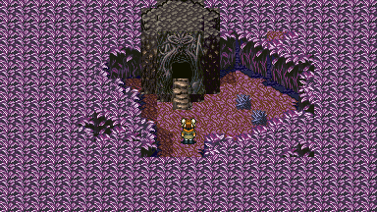

*Mina saw a Cave and entered it.*

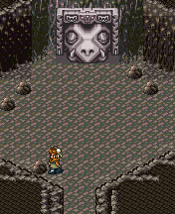

*BEFORE*

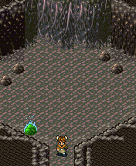

*After*

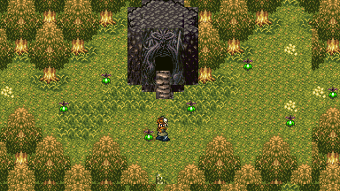

*When Mina went outside the Cave after the rain the place changed.*

2.1.4.2 - Color Keys

2.1.4.3 - Design: In the Dream, I describe it as a healthy land so it does not look like an empty desert or dead place.

**\*\*\*\*\*\*\*\*\*\*\*\*\*\*\*\*\*\***

**2.1.5 Flow Chart**

**\*\*\*\*\*\*\*\*\*\*\*\*\*\*\*\*\*\***

***\*Exploration\****

Rolan saw a cave and enters it. There he saw an unusual head of a giant snake that seems to be sleeping. If you tried to talk on it, it will not respond so there's nothing to do here.

Rolan enters a village, where he saw a girl running. If he speak to her… the girl will say,

"Why should I go to school if I can just read from books what the teacher is telling us?"

"It make no sense right? I rather go have fun outside." and then runs away.

You will hear, a dialogue, coming from her school after that, saying "Miko? Present. Alena? Present! Mina?... Mina?? Absent!!... Absent again? Oh where did that girl go this time."

Rolan, also enters a house where there's a woman cooking yet worried on something. "I hope my Mina got Good grades."

Rolan also encounters her husband outside cutting wood, "It's hard these days, rice is getting more expensive."

If you ignore these events, you will not be able to trigger a special event that follows a mini game.

***\*Mini Game - Follow her and avoid being seen\****

What will happen is when Rolan goes outside, he will saw the Girl, running with her bag pack. You must follow her and avoid being seen. When you reached her in a middle of the road, the rain will fall, and she will run to a cave.

***\*Side Story - Part 1\****

This will trigger an event about her. Her story is that she hates her parents because of making her going to school. And so she leaves. Now she is waiting for the rain to subside.

After that she falls a sleep…

A flashback triggers (A desaturated sprite event), you will see her facing his mother and father having a talk, (here you will understand that her decision to go away is great, because what you will witness is a scene of her father and mother talking about money. She thinks that all they want is money thinking that she will be like a Cash cow to them after she finished schooling. And there she goes away.

When Rolan, follows, he noticed the Girl is gone. He looked left and right and then scratches his head.

The Girl mysteriously disappeared.

***\*Exploration\****

Rolan again is free to explore. Now returns to the village. If Rolan went to the Girl's house, he will see, the Girl is there. (what happened is a mystery.)

***\*Side Story - Part 2\****

The Girl is beside her parents staring the top of the table full of amazing fruits and vegetables. "How on earth you get all of these." The girl laughed and smiled. Both of them looked at her daughter and confused.

The Girl told them…

Then flashback triggers showing the her inside the cave near the entrance. After the rain subside. She went up, her face looks like still wanting to have more sleep. But she became shock of what she saw. She saw something weird and went outside.

"What is going on here?" she said.

She saw bright sky, vibrant trees and rivers. She saw fruits and vegetables and healthy plants. The place before is not anymore like it, it's different and beautiful.

It's like a paradise.

Eventually, she is throwing her stuff out her bag. And then runs away back to her home with her bag full. "Mother! Father!"

"I don't know what happened, but it seems that I sit on something magical."

"It transforms the place outside to a some kind of a paradise."

*(This lines is important. As it gives you clearer hint how you will get inside this mysterious place. If you missed this, you can still explore getting the it.)*

After this, they stop, and the Girl looked at Rolan, "Hey! Why are staring at?" Then she pushed Rolan and closed the door. You will see them going out at the back of the house.

***\*Exploration\****

Rolan is free again to explore, if he proceeds, he may go visit the cave.

***\*Side Story - Part 3\****

The head of the monster appeared facing them, angry. Her father acted immediately to save her daughter and run away.

But the Girl shouted, "No!!! It's not evil!"

But unfortunately… it attacked, using it's Roar.

All of them fainted, including the Girl. Then rolan saw the entrace of the cave shut. He have no choice but to find a way to get inside.

***\*Side Quest - Beat the monster and save the 3\****

When Rolan succesfully got inside, he will fight the monster. He must be cautious as the monster can deal heavy damage and area of effect attack. Rolan must not let it happen so the girl and her parents will not take damage. If Rolan or one of them die the quest will fail.

After the battle, the monster fainted. (Scene Fades)

***\*Side Story - Conclusion\****

After the day, the girl wakes up, she goes down the stairs and she saw Rolan and her parent's are having a conversation. Here she will hear her parents thanking Rolan. "You're parents will be proud of you." (to Rolan) After that, she will hear another that will make her understand what her parents want for her, is to have a stable future that will help her and her future family. Rolan will obtain an bonus item from them, maybe a recovery item.

***\*Aftermath\****

The end is only the beginning. Rolan can now have an access to an optional quest where he can explore more about the monster. Unlike before, he is now allowed to talk to the monster.

**\*\*\*\*\*\*\*\*\*\*\*\*\*\*\*\*\*\***

**2.1.6 Demo**

**\*\*\*\*\*\*\*\*\*\*\*\*\*\*\*\*\*\***

#2 - 2 - A Monster's Dream

Sunday, February 01, 2015

12:30 PM

**\*\*\*\*\*\*\*\*\*\*\*\*\*\*\*\*\*\***

**2.2.1 Overview**

**\*\*\*\*\*\*\*\*\*\*\*\*\*\*\*\*\*\***

**\*\*\*\*\*\*\*\*\*\*\*\*\*\*\*\*\*\***

**2.2.2 Key Ideas**

**\*\*\*\*\*\*\*\*\*\*\*\*\*\*\*\*\*\***

1. (Reward) Rare items that can be obtained inside a room but visually presented as part of a vast place.
2. (Game) Fetch quest and puzzle.
3. (Setting) A cave where there's a vibrant rock that acts as a key to change the setting outside of the cave into something else. That change is a room that looks like part of a vast place. Example: Just a portion of a desert, you cannot go further than what you see on the screen.
4. (Concept) A mysterious monster or Demigod or a symbolical ancient being linked to the power where the obelisk is originated. It's dream is a room that can be accessed by people who steps on a magic Rock.
5. (Concept) An empty room that can turned into a magical room if requirements are met. Grants the player bonus items inside it.

**\*\*\*\*\*\*\*\*\*\*\*\*\*\*\*\*\*\***

**2.2.3 Music Idea**

**\*\*\*\*\*\*\*\*\*\*\*\*\*\*\*\*\*\***

**\*\*\*\*\*\*\*\*\*\*\*\*\*\*\*\*\*\***

**2.2.4 Visual Idea**

**\*\*\*\*\*\*\*\*\*\*\*\*\*\*\*\*\*\***

2.2.4.1 - Draft

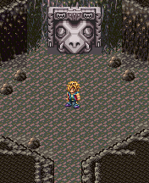

*When Rolan revisits the cave.*

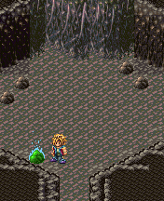

*Notice the stone reveals itself as something with magic, it indicates the change in the place. Also, the mysteriously the head of the monster disappears.*

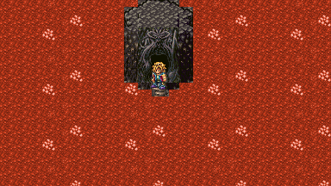

*When Rolan first enter's the mysterious place It's not anymore like what Mina saw.*

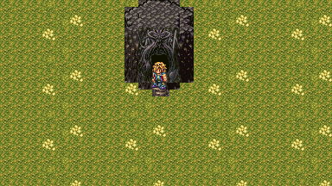

*After Rolan gave some few Items to the Giant Snake.*

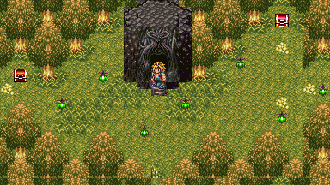

*After Rolan gave more unique items to the Giant Snake. The whole place has now returned to it's original form.*

2.2.4.2 - Color Keys

2.2.4.3 - Design: There will stages of the environment, first is it looks dead, 2nd it will look like beginning to improve, and last will be a health place.

**\*\*\*\*\*\*\*\*\*\*\*\*\*\*\*\*\*\***

**2.2.5 Flow Chart**

**\*\*\*\*\*\*\*\*\*\*\*\*\*\*\*\*\*\***

***\*Exploration\****

Rolan now is free to explore.

Rolan can visit the cave, but the monster don't make sense. (Just like the first encounter) But now, it talks to you.

The monster don't speak human language, except like this,

Monster: 21308…. 9240045…. 6808? 045680? (Like, make no sense.)

It will be revealed, using an amulet maybe, that massage. "I work all of it alone…. Everything… years of work… yet the entire place is now gone... Now I'm working on it again from scratch? How dare you to come and remove my happiness again?

The monster didn't fight, he just shouted "Go Away!!" or "Leave me alone!"

And then, there will be an option of giving him an item that will open your item box.

(The monster is showing its character of someone that you will understand as selfish. But your task is to change it's mind to be a better being.)

You can leave it if you want and continue the main plot. But if you pursue this task, you will be able to unlock secrets.

***\*Side Quest - Recovering the Mysterious Place\****

If you understand a thing "about the stone" Find it and when you sit or step on it, it will make the outside of the cave change. It will change to an "empty room that looks like a desert." If you want to return back just step on that stone again, simple.

This room, the Dream Room, is different to what the girl saw in the first place. The girl saw in the first place is like a "fully furnished" Dream Room (I am using word 'Room' but actually I'm telling that it looks like a part of vast place.) where there are now trees, rocks, recovery items and treasure chest. But now, it looks like an empty box. That Room she saw is *your Goal.*

If you understand what you are going to do, you will get this placed furnished by giving the monster anything.

To be specific, it will make the monster friendly and will allow you to obtain more rare items inside the Dream Room. However, you cannot give him the same item again like you are going to give him potion then another potion again, you cannot, as it will not add into the account.

Each items have their own "Points", like if you give him potion it will add +1 points for improving the Dream Room, but if you give him another again, it will do nothing. Just fill him up with different items and you are going to get improvements of that Dream Room. And when you get there, you will obtain secret items inside. Remember to not give him rare items, as it will not add points and just put it to waste.

***\*Challenge\****

Now the problem is that, you will not know everything about it easily. If you don't pay attention to dialogues that comes from the story, artifacts like books, and NPCs, you won't get any clue. What you will get is only talking to a monster that gives dialogue that make no sense. So there should be some kind of equipment in order for you to understand what the monster is saying.

***\*Solutions\****

You have to travel and explore. Hints and clues will lead you to a revelation that that mysterious place---the girl discovered---is a dream of that monster.

Scattered artifacts that gives information: Mysterious old journals from maybe an ancient tribe or inside a cave or a mysterious room of a dead guy. Rolan collects these in a form of a memo.

**Examples:**

*Book 1: In ancient times, a monster called Wormwood is being thrown away by the Gods. It's been said that it dreams are turning real.*

*Book 2: Gods create worlds by their own imagination. Well, that is what scriptures says.*

*Broken Tablet of Magi: Astar, where we obtain the materials for creating it, is a planet of the highest. Living there are 'Gods' by the way, but they are just advanced civilization gifted with an unlocked power to create a world by imagination.*

*Broken Tablet of Magi 12: We are planning to do something that inspires that ability. A monster that can project a space using its mind.*

*From a possessed Magician: We have figure it out and we did it correctly, we successfully did copy what the highest can do. But unfortunately we failed...*

*Comes from a letter of a dead guy: The monster should obey us yet what we have is a lazy pig. So we just throw it away to the abyss.*

**Aftermath:**

After completing this side quest, you will be rewarded treasures inside the dream of the monster. Now if you want to get more, theres another and final quest you are going to do here. Check the *Nightmare of the Monster.*

**\*\*\*\*\*\*\*\*\*\*\*\*\*\*\*\*\*\***

**2.2.6 Demo**

**\*\*\*\*\*\*\*\*\*\*\*\*\*\*\*\*\*\***

#2 - 3 - Nightmare of the Monster

Friday, January 23, 2015

6:56 AM

**\*\*\*\*\*\*\*\*\*\*\*\*\*\*\*\*\*\***

**2.2.1 Overview**

**\*\*\*\*\*\*\*\*\*\*\*\*\*\*\*\*\*\***

1. Required to finish before the final chapters of the main story. Required to have mysterious items that can be obtain by travelling the world.

*This does not cover the level design yet and the environment design. But we have to plan out what will it be the plot of the dungeon.

The mystery of the dream is telling a Prophecy of Rolan being killed. There will be symbolism that a man is being executed because of the crystals from npcs inside it. And a story of a woman that is being rejected by that man. The cause of it all is the Dark Goddess you have to defeat.

**\*\*\*\*\*\*\*\*\*\*\*\*\*\*\*\*\*\***

**2.2.2 Key Ideas**

**\*\*\*\*\*\*\*\*\*\*\*\*\*\*\*\*\*\***

1. (Reward) Special Items
2. (Game) A Secret Dungeon
3. (Game) A Super Boss - The Strongest Boss in the Game. (The battle field changes depending in it's nature.)

**\*\*\*\*\*\*\*\*\*\*\*\*\*\*\*\*\*\***

**2.2.3 Music Idea**

**\*\*\*\*\*\*\*\*\*\*\*\*\*\*\*\*\*\***

**\*\*\*\*\*\*\*\*\*\*\*\*\*\*\*\*\*\***

**2.2.4 Visual Idea**

**\*\*\*\*\*\*\*\*\*\*\*\*\*\*\*\*\*\***

2.2.4.1 - Draft



*When you enter inside you noticed it is green, after a 5 seconds it will change to Violet and then vice versa, this indicates a change.*

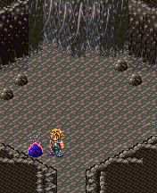

*If you went outside when the rock is green, it will send you the forest environment, but if you go when the rock is blue violet, it will send you to a secret dungeon.*

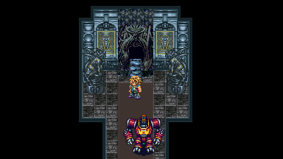

*Rolan Entering the Dungeon from a Dream of the monster.*

*(The contents, mood, environment designs of the area must be weird and changing.)*

2.2.4.2 - Color Keys

2.2.4.3 - Design: The Design of the Dream Dungeon opens a new world, so that means, there could be city around here stopped by time or mixed areas of the world. To be specific, we can use all environment tiles, modify the colors and mix in one dungeon.

**\*\*\*\*\*\*\*\*\*\*\*\*\*\*\*\*\*\***

**2.2.5 Flow Chart**

**\*\*\*\*\*\*\*\*\*\*\*\*\*\*\*\*\*\***

This will only happened if you finished the first quest (The Monster's Dream Quest). And this one will take place later in the game.

***\*Exploration\****

Rolan, returned again to give something to the monster in the cave.

***\*Side Quest - Dream Dungeon\****

After the Dream of the Monster. We now know that you must give the monster items in order for the Dream Room to change. Now think about giving it a specific item. If you explore the entire world of the game, you will notice some items you get are not usual:

1. Goddess Headgear
2. Goddess Armor
3. Goddess Grieves
4. Ulimate Blade
5. Eternal Soul

*These items you get are things 'You cannot use' making you think that it serves no porpose, until you found that it can be given to the Snake, which makes some kind of *connection.*

If you manage to give the monster those, the monster will upgrade the Dream Room to a Dungeon.

This is a secret dungeon and not necessary for the completion of the game.

The boss here looks like the Divine Matron, but it's origin comes from the items you give created by the dream of the monster. Remember this is not a real deity, but a Copycat, if the Divine Matron is white, it's color probably Black and Red.

**Aftermath:**

Beating her grants you a powerful armor or amulet.

**\*\*\*\*\*\*\*\*\*\*\*\*\*\*\*\*\*\***

**2.3.6 Demo**

**\*\*\*\*\*\*\*\*\*\*\*\*\*\*\*\*\*\***

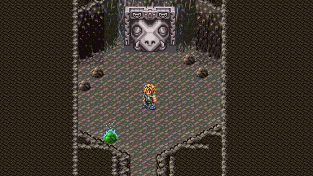

*You can do this after achieving the Monster's Dream Side Quest and after receiving 5 certain items.*

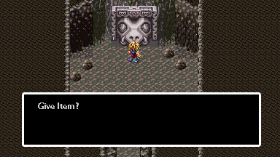

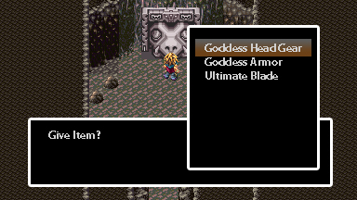

*After placing 'mysterious' items, exit now the place.*

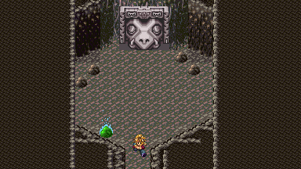

*If you exit when the rock is Green.*



*Leads you to a secret area before.*

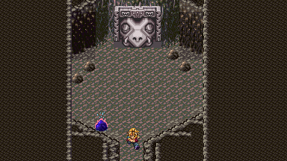

*If you exit when the rock is Blue...*

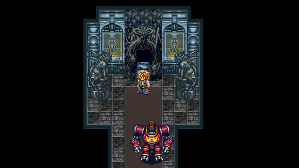

*Leads you now to a secret dungeon*

#3 - 1 - The Thief

Tuesday, January 27, 2015

11:27 AM

**\*\*\*\*\*\*\*\*\*\*\*\*\*\*\*\*\*\***

**3.1.1 Overview**

**\*\*\*\*\*\*\*\*\*\*\*\*\*\*\*\*\*\***

**\*\*\*\*\*\*\*\*\*\*\*\*\*\*\*\*\*\***

**3.1.2 Key Ideas**

**\*\*\*\*\*\*\*\*\*\*\*\*\*\*\*\*\*\***

1. (Rewards) Rolan will rewarded a magical ring that Drains life when active. (Core)
2. (Game) A memory game. Player will be challenged his memory. (Core)
3. (Game) The Boss is slight strong than the Sword Tree Boss.
4. (Design Theme) A horror theme setting. (Core)

**\*\*\*\*\*\*\*\*\*\*\*\*\*\*\*\*\*\***

**3.1.3 Music idea**

**\*\*\*\*\*\*\*\*\*\*\*\*\*\*\*\*\*\***

1. Since it's a horror theme place, there 's no music at all but sound effects based in real life during night time.

**\*\*\*\*\*\*\*\*\*\*\*\*\*\*\*\*\*\***

**3.1.4 Visual Idea**

**\*\*\*\*\*\*\*\*\*\*\*\*\*\*\*\*\*\***

3.1.4.1 - Draft

The interior still looks new, and well lit with lamps at first. However, there is no sign of people here, even pests are none. But you'll see some prepared food on the table as if there should be some guests.

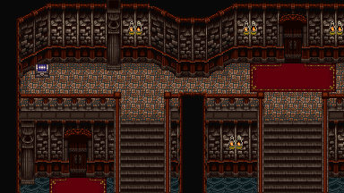

When the player progresses the place is starting to get spooky like the place is turning dark or the lights are turning off, the pictures is showing changes, also random sounds of laughing child or a woman.

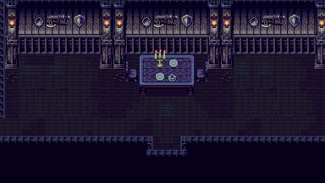

3.1.4.2 - Color Keys - From warm and lively to Dull and Dark

3.1.4.3 - Design: Mansion interior. If you see the exterior you will notice that it is not haunted.

**\*\*\*\*\*\*\*\*\*\*\*\*\*\*\*\*\*\***

**3.1.5 Flowchart**

**\*\*\*\*\*\*\*\*\*\*\*\*\*\*\*\*\*\***

***Exploration:***

Rolan encounters a thief guild that is obsessed in obtaining a certain magical ring. Some of them will tell you about a mansion and a path where it is located… If you manage to go there and explore, you will see a opened gate that is closed before, it leads to a mansion.

***Side Story:***

The mansion's history tells a story of a theif that enters it, he is from a thief guild assigned to steal a ring in the mansion. The Guild is same to the one Rolan encounters in the town.

In the beginning, theres a note that can be found at the entrance of the mansion, that note acts as a "key item" that triggers flashback whenever Rolan steps on a check point.

All flashbacks are scenes of the theif in greyscale. Rolan must follow the path where the theif went. If Rolan fails, he will return back to the entrance and go thru from scratch again.

*It's a memory game*, and the horror theme adds the atmosphere of the place as part of the challenge.

If Rolan reached the last check point, he will witnes the thief in a room where he sees a note revealing the truth that the mansion is a magical hologram made by the ring. After reading, he was attacked by a monster and then the flashback black out.

Now that monster appears in front of Rolan and tries to attack. Rolan fights it.

After beating the monster. The mansion turned into an old broken place. And a ring gem appeared in front of Rolan to keep. That ring gem, can be something that can give Rolan Drain ability or something dark. The monster also will give a great amount of money.

(Origin: The mansion is only a presentation of the Ring's ability. That is why the monster here eats people who enters the mansion and regain health that reflects the healthy look of the mansion.)

If you went back to the theif guild, it will ask you something if you have the ring, saying it's a curse like "you must not have that ring because it’s a curse, surrender it to us so you will be safe." But actually you don't need to, if you think of it as valuable. If you sell it to them they will pay you same money you get from the monster. It's up to you if you sell it or not.

**\*\*\*\*\*\*\*\*\*\*\*\*\*\*\*\*\*\***

**3.1.6 Demo**

**\*\*\*\*\*\*\*\*\*\*\*\*\*\*\*\*\*\***

This is a horror themed memory game. So the design of the area must feel scary, and a Good reference for me is Silent Hill, Resident Evil or Mad Father. Hopefully there are jump scares we can input here as well.

The memory game part, is like Follow the leader, you follow the Theif in the Flashback. By accomplishing this serves the player to get to the next room or level.

There are 2 types of challenge we can do.

1. following the player where he went like if A go to Door A, the player too must go to the Door A as well, there will be long walk for him to get to that door after receiving a flashback so the player must keep it in mind. ,
2. following exact footsteps.

Demonstration:

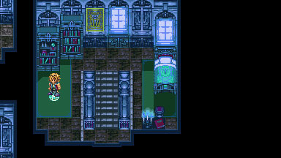

Rolan steps on an indicator. If Rolan have the notes from the Guild, it will trigger a flashback.

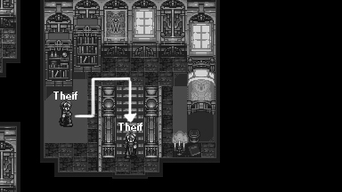

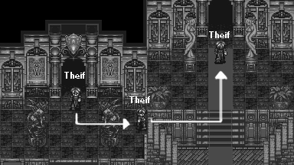

After the flashback, Rolan must follow where the theif goes.

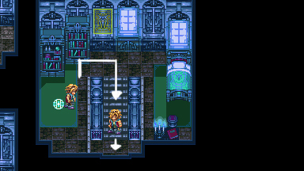

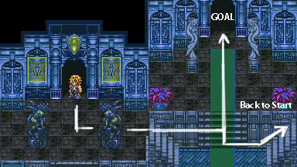

If Rolan went to the wrong way, he will return back at the entrance.

#5 - 1 - The Bridge

Monday, February 02, 2015

2:36 PM

**\*\*\*\*\*\*\*\*\*\*\*\*\*\*\***

**5.1.1 Overview**

**\*\*\*\*\*\*\*\*\*\*\*\*\*\*\***

A very simple story with a gameplay of escorting. 2 siblings wants their parents to be proud of them. They are treated worthless and stupid who don't know how to farm. So they want to show their worth by deliving the things to sell to the city. But the problem is the route they are going, there a many monsters. Will Rolan escort them?

**\*\*\*\*\*\*\*\*\*\*\*\*\*\*\*\*\***

**5.1.2 Key Ideas**

**\*\*\*\*\*\*\*\*\*\*\*\*\*\*\*\*\***

1. (Rewards) Boost equipments and a Lucky Charm
2. (Game) Escort mission
3. (Game) There are 4 stages and each stages are leveled from easy to hard and it's because of the level design of each stage. And one final stage that compose of 3 mini games based from the first 3 stages, except new prices.
4. (Setting) The place outside is a field, and somewhere is a cliff that is a safe path, that makes you think that if you build a bridge there it will make easy for the people to travel the place safely.

**\*\*\*\*\*\*\*\*\*\*\*\*\*\*\*\*\***

**5.1.3 Music Idea**

**\*\*\*\*\*\*\*\*\*\*\*\*\*\*\*\*\***

**\*\*\*\*\*\*\*\*\*\*\*\*\*\*\*\*\*\***

**5.1.4 Visual Idea**

**\*\*\*\*\*\*\*\*\*\*\*\*\*\*\*\*\*\***

5.1.4.1 - Draft

5.1.4.2 - Color Keys

5.1.4.3 - Design

**\*\*\*\*\*\*\*\*\*\*\*\*\*\*\*\*\*\***

**5.1.5 Flowchart**

**\*\*\*\*\*\*\*\*\*\*\*\*\*\*\*\*\*\***

2 Youngsters are wants their father and mother to be proud of them, but they worthless for them and stupid who don't know how to farm. So they want to show their worth by deliving the things to sell to the city. But the problem is the route they are going, there a many monsters. Rolan can escort them

The first stage - You have to escort the children riding a car with the package, you have to protect them from the monsters: After finishing the the escort mission a cutscene will be shown, the 2 are happy expects that their parents will be pleased, but instead they are treated badly, their father kick them out and didn't gave any food. If Rolan talks to them, they will say that they have a plan.

The second stage - You have to escort the children again going in a different route and city: After finishing, there will another cutscene that shows that their parents are talking about putting their children to orphanage. The 2 youngsters are in struggle to not make that happened, so they ask a chance from them. This will reveal, another mission for Rolan.

The third stage - You have to escort the children again going to another route: After finishing this, you will see another cutscene that shows their parents talking to a person that looks like someone will take over them. They reveal that they are not their true parents and they are sold to that man, and the man is someone that don't take the children to the right place but to slavery. Rolan must save them.

The forth stage - You have to escort them while protecting them from the man and his dogs. Unlike the first mission, the monsters here are agressing and following you. If you happened to finish this stage, you will put the children to trusted person npc that takes children and free school. After this, you thought it's already finished, now take the fifth stage.

The fifth stage - After finishing some quests, a crazy escort mission for the last time, you will see a puppy in the town that if you get near of it it will will go outside. If you follow it, you will have to protect it travelling to the next town, specifically to the daycare, if you fail, it will return back to the town. If you successfully made it, the puppy will be taken by the daycare saying it as their lost puppy. You will be informed that the children are Gone, the manager are happy about them.

Now you will see a bridge to other side is now being built, and passing it allows you to instantly go to other side place (This just a setting shortcut maker). And you will see the children in the gate, guarding it and managing it. They said that they obtain something hidden, that made them rich and build a bridge. But they just give it up to Rolan as a sign of gratitude. A Lucky Charm (Boost luck greatly or chance of doing critical. This ends up the their story but opens a mini game of escorting people, handled by that children. Rolan can do mini game of escorting people in 3 areas like before. If you manage to get the best score you can win an Exp boost amulet or Str Boost or Stats boost equipments.

**\*\*\*\*\*\*\*\*\*\*\*\*\*\*\*\*\*\***

**5.1.6 Gameplay**

**\*\*\*\*\*\*\*\*\*\*\*\*\*\*\*\*\*\***

#6 - 1 - That Girl's Arena

Monday, February 02, 2015

2:36 PM

**\*\*\*\*\*\*\*\*\*\*\*\*\*\*\***

**6.1.1 Overview**

**\*\*\*\*\*\*\*\*\*\*\*\*\*\*\***

A girl opens up a battle ground searching for the strongest warrior. In the end, the girl will reveal herself as the contender, she is 'known' but not saying as the strongest fighter in the game.

After beating a certain amount of unique monsters in the game. You will gain recognition and a group of mysterious people is going to capture you and put you to a new setting where a unknown arena is placed. A female contractor will tell you about the place that will lead you to a set of monsters to battle. If you manage to beat all of them, you will be freed. The Girl will give Rolan her contact, telling Rolan can visit anytime if he is interested to battle more monsters.

If you manage to beat all monsters, the girl will surprice you to battle her. She will give the reason why she made the area is to discover her true "partner".

The Girl is not a villian, she's just childish and her reason is crazy.

**\*\*\*\*\*\*\*\*\*\*\*\*\*\*\*\*\***

**6.1.2 Key Ideas**

**\*\*\*\*\*\*\*\*\*\*\*\*\*\*\*\*\***

1. (Rewards)
2. (Game) Arena.
3. (Game) Super Boss: Less stronger to the Monster's Dream Boss.

**\*\*\*\*\*\*\*\*\*\*\*\*\*\*\*\*\***

**6.1.3 Music Idea**

**\*\*\*\*\*\*\*\*\*\*\*\*\*\*\*\*\***

**\*\*\*\*\*\*\*\*\*\*\*\*\*\*\*\*\*\***

**6.1.4 Visual Idea**

**\*\*\*\*\*\*\*\*\*\*\*\*\*\*\*\*\*\***

5.1.4.1 - Draft

5.1.4.2 - Color Keys

5.1.4.3 - Design

**\*\*\*\*\*\*\*\*\*\*\*\*\*\*\*\*\*\***

**6.1.5 Flowchart**

**\*\*\*\*\*\*\*\*\*\*\*\*\*\*\*\*\*\***

After beating a certain amount of unique monsters in the game. You will gain recognition and a group of mysterious people is going to capture you and put you to a new setting where a unknown arena is placed. A girl will introduce herself and leads you to fight strong unique monsters in the Game, usually, the father of it's kind. After finishing 7 monsters straight you will be rewarded and gain freedom (End of story).

In continuation, this will open a mini game arena, you can return back to this new place on the map. You will be given access to fight a new set of monsters.

If you manage to beat the arena, the Girl will fight you, saying that the reason why she made the arena is too look for someone who is strong to handle her.

If you beat her, the Girl will give Rolan a special item or equipment. (She will say that she is looking for a "Real man")

**\*\*\*\*\*\*\*\*\*\*\*\*\*\*\*\*\*\***

**6.1.6 Gameplay**

**\*\*\*\*\*\*\*\*\*\*\*\*\*\*\*\*\*\***

#7 - 1 - Caroline's Grey Castle

Friday, January 23, 2015

11:17 AM

**\*\*\*\*\*\*\*\*\*\*\*\*\*\*\***

**7.1.1 Overview**

**\*\*\*\*\*\*\*\*\*\*\*\*\*\*\***

Required to finish the Night of the Monsters

She is a cute/sexy girl with a large hammer weapon, she is one of the Secret Boss in the story. She is a user of a strange art of Blacksmith. She can break the nature making the elements change to another element using her Hammer Skill. And every of her magic attacks are in full power meaning you can easily die with just one hit. Honey has an ability to capture molecules, and that he can use it as a source to blast super strong magic. Additionally, if she uses her Hammer Skill, it will trick you that what you are getting is not the element you expect. Like if she blast you fire, instead of elemental flame, you will receive a water element. However, it's primary weakness is she is predictable and slow.

When Rolan met her, she will give some tasks to do, and those tasks eventually will reveal her story. This part will be the game.

Her story tells about her passion of her hobby, Improving her Hammer Skills. She left her family as she don't want to be controlled and forced to do something she don't like, like fixing her marriage and career. Her father don't like her hobby, he think its only a waste of time. Because of that, She leaves and move on to follow her dreams. In the end, she became a powerful being after discovering the great knowledge. She gain her own place a Grey Castle, where she lives as a Queen.

But in the end, Rolan will fight her, for reason of getting a strong piece of item. Rolan will not kill her but defeat her arts she proud of.

**\*\*\*\*\*\*\*\*\*\*\*\*\*\*\*\*\***

**7.1.2 Key Ideas**

**\*\*\*\*\*\*\*\*\*\*\*\*\*\*\*\*\***

1. (Game) Super Boss - The Boss battle style may put you to challenge more that the strongest boss. The strongest Boss requires you best equipments, and best stats and higher level. But this boss, will require your intelligence.

**\*\*\*\*\*\*\*\*\*\*\*\*\*\*\*\*\***

**7.1.3 Music Idea**

**\*\*\*\*\*\*\*\*\*\*\*\*\*\*\*\*\***

Boss Battle music: Pop

**\*\*\*\*\*\*\*\*\*\*\*\*\*\*\*\*\*\***

**7.1.4 Visual Idea**

**\*\*\*\*\*\*\*\*\*\*\*\*\*\*\*\*\*\***

7.1.4.1 - Draft

7.1.4.2 - Color Keys

7.1.4.3 - Design

**\*\*\*\*\*\*\*\*\*\*\*\*\*\*\*\*\*\***

**5.1.5 Flowchart**

**\*\*\*\*\*\*\*\*\*\*\*\*\*\*\*\*\*\***

**\*\*\*\*\*\*\*\*\*\*\*\*\*\*\*\*\*\***

**5.1 .6 Gameplay**

**\*\*\*\*\*\*\*\*\*\*\*\*\*\*\*\*\*\***